Motor skills for a student-athlete
Student
School name
Instructor:
18/09/2018
Introduction
A student athlete will need motor skills, which are important for different coordinated tasks for various sporting goals. The basic movement skills is the first step towards learning of different athletic sports activities and performance that the student should be aware of. As a professional trainer or coach, it is important to make good training decisions that will ensure strength and conditioning of the student muscles, and body to get fit for sporting activities. For example, the motor movement classifies sporting skills to a number of categories that can be used in coaching (McMorris, 2014).
What the student-athlete should learn
Closed motor skills is performed in self-paced environment whereby there are minimal interruptions from the surrounding environment. This can be done in a field, a hall, or any other indoor archery. The skill in this motor usually involves little movement. For example gymnastics where the student athlete tries to replicate movements such as swings. For example ten-pin bowling. On the other hand, open motor skills involves changing the external environment, speed and the height of waves or speed of a ball. Closed skills are usually easy to practice and learn. This means that the student-athlete can learn the closed skills faster that open motor skills (McMorris, 2014).
In the skill development process, the student-athlete should be eager to practice any of the motor skills in the game situation. For example, in the real game the student-athlete should effectively apply the skill mastered to hit and control the ball or use the ball machine perfectly.
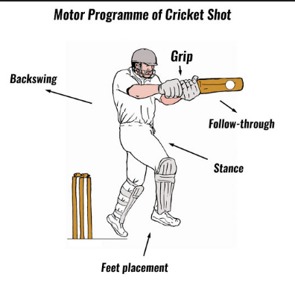
Other skills that could be helpful to the student-athlete include the fine and the gross motor skills. In the fine motor skills, the student athlete learns to use small groups as well as body senses such as touch, sense, and sight. For example, the student-athlete is able to apply the motor skills in timing the tennis ball and hit it back to the opponent perfectly. The same applies to shooting of the archery. In the gross motor skills, the student is expected to apply large muscle actions in a more coordinated effort to produce rhythmic movement in the sporting activity such as shooting, dancing, hitting, or throwing.
Evidence to the supervisor that the student-athlete can demonstrate these skills
The motor skills once acquired by the student-athlete can be demonstrated in the game situation. The student-athlete should be able to apply the skill in the real game. A good example is when the student-athlete plays the lawn tennis ball. He/she first drops the ball then proceeds to hit the ball over the net. After the student-athlete gets the beginner experience, he/she should be able to randomly apply a variety of positions in hitting the ball from all the angles of the court. The program should also equip the student-athlete with the right knowledge, skill, body structure, and fitness (McMorris, 2014).
Confidence that the evidence meets criteria for motor skills
In this learning process, learning of one skill should help the learner to progress and learn other skills automatically. This is known as positive transfer of skills. For example, learning of a chess pass in basketball should be directly transferred to learning a chess pass in tennis (Honeybourne, 2016).
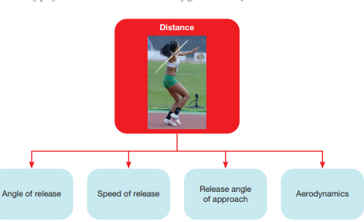
The learning process also looks into the body health whereby the student-athlete should be educated on personal diet and body fitness. It is not okay when the student is obese after going through all the learning process and deem the criteria credible. The student should be guided towards body fitness and the general individual constraints. Psychologically and mentally the student-athlete ought to be guided which maximizes skill learning, and the ability to process information progressively. Rules of the game must be adhered to. Every game has its own rules, requirements and it is the duty of the coach to ensure that all the rules or requirements are adhered to (Honeybourne, 2016).
In conclusion as a coach, it is important to implement the most effective technique to the student-athlete that will enable them to grasp the motor skills and implement them accordingly. As a coach, there is a reason to use traditional techniques that will work for the learner depending with the body size, weight and height or any other special feature of the student.

References
Honeybourne, J. (2016). Acquiring skill in sport. New York: Routledge.
McMorris, T. (2014). Acquisition and performance of sports skills. Chichester, West Sussex, England: J. Wiley & Sons.

